{ourney Steps

W:n”ch *tep of the experience are you de*cr:'b !ng 2



W:nat d oes the

cu*to •ne • do ! W:nat informaiion do they loo ñ fo * What is their co nrext?

Discovery

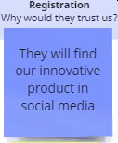Why do they even start the journey?



###### They search for good child safety gadget in social media



Why would they irnztre others?



Needs and Pa ins

What d oes the customs want @ .

to ach eve or avoid ?

7io. *Redme omnigui ,* eg. zy

Rechuce be crime happened to the children by tracking the

To.hamea

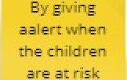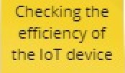

### May not kno*w* how to use the



Ok dhé•

##### zgert

messages

cléf4nen lheszmny

us.'ng rñe rs• oersorz n orrotor.

### children

1.Aware

child‘s location in

google map

#### T.Social

devtre

###### de tee

gadget

1.Live

Tou ch point

W:nat part of th e service d a t ney intera ct v/”th !

What is the custome fee in g * 7ip. Use */-e etnoji opp to axoress more emo•.'one

## ore«rtuna ..

-Inform and educate

-Chart solution to problem

##### What couId 'x.e ”morove o•

inc•oduce !

# the people 2.Social media



###### Interested,hesitant

media/Ads 2.Website 3.Blogs



1.Phone call 2.Email enquiry

envi ronmenc 2.Knowledge base

3.5 upporc



Collect feedback actively

Increase/decrease a leading metric by comparing costs

Considered the location and price.



###### Refer the friends in social media after the first

PNT2022TMID33026

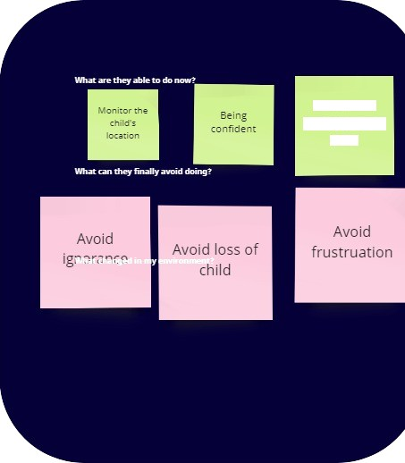

Ensure the

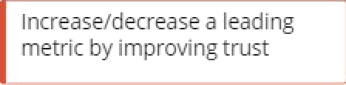

Increase/decrease a leading metric by improving trust

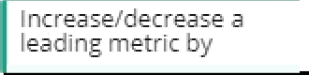

I ncrease/decrease a leading metric by